Text in blue is for instruction only and should be deleted.
Text in black should be included if appropriate for the trial.

SOP Ref No Insert trial title_SOP00

SOP title Data Coding

Version Insert number 0.0

Date issued Insert date DDMMMYYYY

Valid until Insert date DDMMMYYYY

Author(s) Name:

Signature:

Date:

Approved by Name:

Signature

Date

Modification history

Version No | Date | Author(s) | Date reissued to previous recipients
- Purpose
The purpose of this standard operating procedure (SOP) is to outline the procedures required to complete coding of medical conditions and treatments recorded on the insert trial title CRFs and clinical trial database.

- Scope
This SOP describes the coding activities which need to be carried out, prior to reconciliation of SAE forms and locking of the clinical trial database.

- Responsibility
The Medical Coder will be responsible for assigning the medical condition and/or treatment a standard medical dictionary term according to his/her professional opinion. The Data Managers and will be responsible for coordinating the coding processes (collection, discrepancy management, coding maintenance). Ensuring medical conditions and medications are standardized using medical coding dictionaries and if necessary liaising with database programmers to facilitate the update of database menus and dictionaries. Data Entry staff will be responsible for entering data according to the predefined coding lists (e.g. drop down menus). The Clinical Project Manager will provide oversight of the complete coding process.

- Definitions
Investigators report medical events and treatments in many different ways (called verbatim terms) on the CRF/eCRF. In order to compare the frequency of adverse events in drug treatment versus non treatment group the terms need to be classified into standardized terminology. These groupings can then be reviewed, analyzed and shared with regulatory authorities.

MedDRA : Medical Dictionary for Regulatory Activities
WHO DDE : World Health Organization Drug Dictionary Enhanced
CRF : Case Report Form

- Procedure

Prior to medical coding
- During CRF and database design, codes will be assigned to certain questions to standardize free text responses.
- Codes may be numeric but may also be just another text version of the preferred term i.e. Pain in head would be standardized to headache.
- Providing pre-defined coding lists of medical conditions and treatments to sites may limit the amount of problems with coding as variations of the reported term, such as misspelling, hard to read abbreviations and use of symbols may make coding more difficult.
- Sites should also be instructed to report the main medical event and not individual signs and symptoms.

Medical coding
The Data Manager should ensure that all medical conditions and treatments recorded on clean and validated data is checked against the medical coding dictionaries:

- Medical conditions – MedDRA (Medical Dictionary for Regulatory Activities)
- WHO DDE (WHO Drug Dictionary Enchanced)

Verifies the following:
MATCH = auto coding completed. The terms listed on the CRF exactly matches the appropriate term in the medical dictionaries.
- The Data Entry persons enters data according to the predefined coding lists.
- Or if the code is not already on listings. Pre-defined paper and database coding lists plus drop down menus should be updated. The Data Entry person updates the database and the study statistician is also informed of any coding changes.
DO NOT MATCH = further clarification required from Site Investigator. Auto coding fails the terms used are unclear because they are abbreviated, illegible, there are spelling errors, multiple signs and symptoms are recorded as separate events or the event is recorded without a site e.g. ulcer recorded without additional information leg ulcer.
- A discrepancy should be raised and further clarification sort from the Site Investigator.
- Following return of the response to the discrepancy the Data Manager will review and assess whether the forms terms match and can be entered on the database or require manual coding by the Medical Coder.
DO NOT MATCH = manual coding completed by Medical Coder. Auto coding fails and the terms given do not match any of the terms in the medical dictionaries.
All terms will need to be manually coded by the Medical Coder.
- The Medical Coder will then assign the unmatched medical condition or treatment with a code from the coding dictionaries, based upon their expert opinion.
- The Data Entry persons enters data according to the predefined coding lists.
- Or if the code is not already on listings. Pre-defined paper and database coding lists plus drop down menus should be updated. The Data Entry person updates the database and the study statistician is also informed of any coding changes.

Example of Flow Chart for Medical Coding see Figure 1.

Figure 1: Flow Diagram of Medical coding

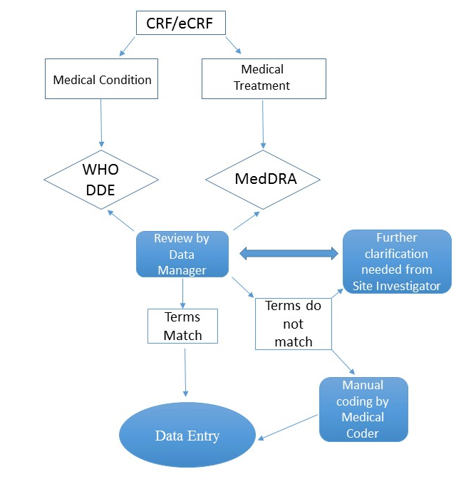

- References
  - Insert trial title SOP00_ Data Entry SOP V0.0. DDMMMYYYY
  - Insert trial title SOP00_ Data Query SOP V0.0 DDMMMYYYY
  - Insert trial title SOP00_ Data Management Plan V0.0 DDMMMYYYY

